Compact Automated Waste Sorting System (CAWSS)

## 

## University of Central Florida

### Department of Engineering and Computer Science

#### Dr. Lei Wei, Samuel Richie, and Aravinda Kar

#### EEL 4914: Senior Design 1

### Initial Project and Group Identification Document

### (Divide and Conquer 1.0)

## Group 1

|  |  |
| --- | --- |
| Melissa Siver | Photonic Science and Engineering |
| Troy Rzeznikiewicz | Photonic Science and Engineering |
| Clyde Bujari | Computer Engineering |
| Juan Soto | Electrical Engineering |

### 

### Table of Contents

1 - Executive Summary

2 - Project Description

2.1 - Motivation and Goals

2.2 - Objectives

2.3 - Requirements and Specifications

2.4 - Quality of House Analysis

3 - Research Related to Project Definition

3.1 - Existing Similar Projects and Products

3.2 - Relevant Technologies

3.3 - Strategic Components and Part Selections

3.4 - Parts Selection Summary

4 - Related Standards and Realistic Design Constraints

4.1 - Standards

4.1.1 - Standards Search

5 - Project Hardware and Software Design Details  
 5.1 - Initial Design Architectures and Related Diagrams

6 - Project Prototype Construction and Coding

7 - Project Prototype Testing Plan

8 - Administrative Content

8.1 - Milestones  
8.4 - Budget and Finance Discussion

Appendices

### 

### 

### 

### 

### 

### 

### **1 - Executive Summary**

### **2 - Goals, motivations, and objectives motivation, project goals, project objectives**

#### 2.1 - Introduction

Identifying post-consumer waste as a recyclable material can be a very daunting task for the average individual and the consequence of misidentifying waste can further complicate the waste sorting process. Not only does misidentified waste decrease efficiency of the waste sorting process, these pieces have to be individually picked out by employees which can slow down the rate at which the sorting facility processes recyclables. This can also lead to many other problems such as damage to equipment, cross contamination of other recyclable materials, and environmental issues.

Our team plans to eliminate this issue by developing a compact waste sorter that can be used anywhere that there is a waste bin for post-consumer waste. We will eliminate human error when designating an item as recyclable or non-recyclable by obtaining the spectra of the item in question, using software to aid in the assessment of recyclability, and then feeding it into its appropriate destination within the bin. This will be self-contained in a structure that will house a conveyor belt for moving waste, a near-infrared spectrometer for obtaining a spectral reading, and a flapper for physically moving the waste to its appropriate destination. This process will utilize energy recovery in the form of solar panels to reduce its carbon footprint.

#### 2.2 - Motivation

As humans, disposing of waste daily is an inevitable fate that is often met with the option of placing an item into a recycling bin or a trash bin. We face the question of “Is this able to be recycled?” almost every day, which many times ends up in something called wishful recycling; the process of tossing non-recyclables in the recycling bin hoping for them to be recycled. While most people assume identifying a waste item as trash or recyclable is easy, it can be quite troublesome for others. The process of identifying materials as recyclable can be even further complicated when local and state guidelines change the criteria for recyclability. This problem is further exasperated when consumers travel outside of their natural environment and are under a different set of local guidelines for recycling. This can appear to be a careless mistake but it actually can have a significant impact on the efficiency of the recycling process.

Wishful recycling has recently been identified by organizations such as the Sierra Club and the Watershed Project as one of the biggest threats to the long term sustainability of recycling programs in the United States. Additionally, a case study done in Arcata, California estimates that 25% of the waste that comes through their recycling facility ends up in a landfill with an average cost of $12 per customer each year as a result of the extra sorting time it takes. This evidence makes it clear that people are not as good as they think at making informed decisions on the recyclability of their waste. Not only are these mistakes costly to the recycling facilities that then have to hand-pick and ship these non-recyclable materials to other processing facilities, these materials can also contaminate potentially recyclable materials which even further intensifies the need for a better recycling system.

Current designs of trash and recycling cans have been almost unchanged in the past 4 decades. Our team believes that not only would a design change be advantageous, it would have a significant impact on the future of recycling by erasing some of the biggest challenges pertaining to the sorting waste. The design of our system brings peace of mind to the user that their post-consumer waste is almost guaranteed to go to the correct destination, resulting in a more profitable, efficient, and sustainable recycling program.

Our design team intends to solve this problem using fairly understood optical sorting methods that can be applied to a compact waste sorting system. We not only intend to minimize the amount of non-recyclable items that enter the waste sorting system each and every day but we also aim to replace conventional dual-purpose trash and recycling bins with our Compact Automated Waste Sorting System, otherwise known as CAWSS. The total size of our system would be roughly the same cubic size as a conventional trash can. This system will be capable of differentiating waste items with a high degree of accuracy to ensure an increase in the efficiency of the waste sorting process. This will all be achieved through the use of Near Infrared Spectroscopy (NIRS) being implemented with custom software to identify and compare emission spectrums of a multitude of materials. Our system will then physically sort the waste item through the use of a conveyor belt, a flapper powered by servo motors, and a gravity shute.

#### 2.3 - Function of Project

The primary function of this project is to be able to develop an apparatus capable of screening materials, designating them as recyclable or non-recyclable, and sorting them into their destination. With this, we plan to reduce human-error and be able to increase the efficiency of sorting facilities. This will not only take the burden off of the user to spend time deciding if an item is recyclable but it also will have many benefits in sorting facilities, as mentioned above.

The first function of our system would be to accurately sort materials apart from each other based on recyclability. Our highest probability of success in relation to our budget and time to develop would be to utilize Near Infrared Spectroscopy (NIRS) in combination with a software program in order to accurately separate trash from recyclable materials. Another function of our system would be to physically separate the materials into their appropriate designations by the means of a conveyor belt. The conveyor belt functions as a mechanism that would move the waste from its entry point, through the spectrometer, and then into the appropriate bin. On the end of the conveyor belt, a flapper powered by a motor will function as the sorting mechanism that will push the waste into the trash bin or the recycling bin.

#### 2.4 - Goals

The primary goal of this project is to create a functional optical sorter that can be used anywhere that there is a waste bin for post-consumer waste. Our largest goal is being able to successfully obtain a spectra of waste items using spectroscopy that will utilize software to compare the spectra of test items against known recyclable materials. We plan on using NIR (near-infrared) spectroscopy to obtain these readings. The items will be fed into the bin from a hopper onto a conveyor belt where a spectral reading will be taken of the item as it passes. After this, software will aid to make a decision where a flapper will then push the waste to either the recycling or non-recycling side of the waste bin. This will allow sorting facilities to run at higher processing rates as well as avoid cross contamination from non-recyclable items.

When comparing our system to the industry standard, portability is a large selling point for some of the most popular designs of current waste bins being used. Portability and ease-of-use is a very important design factor for our team as we continue to develop our design. This will allow for our system to be no less portable than current waste bins being used, allowing for people to move our system around the same as they would a normal waste bin. By making our system portable, this could provide us with a unique advantage over several non-portable waste bins that are commonly used in public.

We aim to make this compact sorter as user-friendly as possible while maintaining a relatively high degree of accuracy. One of the ways we are going to be able to achieve user friendliness with our device is to have the device on standby until a piece of trash is detected by the sensor in which case the process would start. This would allow for the consumer to use our system in the same manner as a conventional waste bin without the need for identifying the item they are throwing away. The only user input required will be the trash placed in the system. We also intend to make this system user-friendly for the people that will be emptying it as well as any maintenance or minor repairs that need to be completed.

Another primary goal our team has for our project design is to implement technology into the design that we believe has the possibility of being manufactured for cheaper in the future based on the scale of production. It is not our intention to produce a system for research of plastic emission spectrums but rather we intend to produce a system that can function, compete, and accomplish what other waste containers currently do not. In order to achieve this, we will be choosing components and technologies that are commonly used and have the potential of being built either in-house or sourced for a lower cost as the design becomes more refined.

Eye safety is of the utmost importance when it comes to integrating optics into commonly used products such as our own. Although it is possible to obtain more accurate spectral readings using destructive or non-eyesafe techniques, part of the reason why we chose NIR spectroscopy was because of the limited risk it carries to the consumer when using the device. Not only will this ensure our team's safety in the design and production stages of our system, it will also ensure the consumers safety while making the possibility of FDA compliance much simpler as it will be using eyesafe techniques.

Lastly, our long term goal is to have this system partially solar powered to offset the energy consumption when in operation. This will be achieved by using solar panels mounted to the system which will be in operation when the system is used in an outdoor application, enabling additional energy recovery to an already more environmentally sustainable method of recycling. While we understand that powering this entirely from solar panels may be unfeasible in our current design stage, we are designing the system to utilize less power via standby mode and energy efficient components with hopes of one day powering the system entirely through renewable sources.

#### 2.5 - Objectives

When considering the objectives necessary in order to confidently achieve our goals, we tried to consider it from a technological and financial standpoint that would best reflect our priorities. Below are several objectives that will better help us reach quantifiable goals throughout our design process. While many of these objectives could be improved upon in the future, these are the minimum objectives needed to obtain proof of concept and a working prototype under our current design constraints.

1. We are determined for the cost of our project budget of materials to be under $1,500.00 not including the cost of time spent in development, production, and testing.
2. We are determined to be capable of obtaining an emission spectrum of 1000-1600 nanometers in order to properly differentiate materials.
3. We are determined to have the system operating in standby mode with a power consumption of less than 10 Watts.
4. We are determined to obtain partially power our system by using solar panels
5. We are determined to achieve a 95% rate of accuracy in properly identifying qualifying materials that passes through our system
6. We are determined to complete the final prototype of our system by the end of Senior Design 2 in December, 2021.

#### 

#### 2.6 - Requirements Specifications

##### 2.6.1 General Requirements

This device should implement the following general behavior, in two main

modes:

* Standby mode
  + Conserve power while idle.
  + When trash input is detected, return to active mode.
* Active mode
  + Move/align trash to spectrometer.
  + Analyze the trash to classify it.
  + Direct trash to its correct destination.
  + Return to Standby mode.

##### 2.6.2 Housing

The housing of the device should:

* Have two separate compartments for plastics and non-plastics.
  + Allow easy access to these compartments to empty them.
* Have enough space to fully enclose all components of the design.
* Include an isolated space for spectral analysis, minimizing external light sources.

##### 2.6.3 Delivery Mechanism

The device’s conveyor belt should:

* Be large enough to accommodate the types of trash we expect to deal with.
* Move slowly enough to allow for accurate spectral analysis.
* Consume as little power as possible.

##### 2.6.4 Spectrometer

The spectrometer used in this device should:

* Be able to detect transmission spectra between 900 and 1600 nm.
* Be able to provide an accurate spectrum with enough resolution to differentiate plastics from other waste.
* Be resistant to water and waste materials
* Be able to be operated with low power
* Cost under 800$
* Be able to resolve spectra within reasonable amount of time
* Maintain and control thermal stability
* Meet electrical safety standards
* Proper labeling with safety specifications

##### 2.6.5 Sensors

Sensors in this device, other than those used for spectral analysis, should:

* Detects when a user interacts with the device while in standby mode.
  + Trigger a processor interrupt event when this occurs.
* Detect when trash on the conveyor belt approaches and exits the spectrometer system.
  + Begin and end analysis on these triggers.

##### 2.6.6 Processor

The processor used for this device should:

* Provide sufficient analog/digital input for spectral data and all other sensors.
* Provide sufficient output to control motors and spectrometer light sources.
* Provide sufficient memory/processing power to analyze spectral data.
* Provide a low-power mode (LPM) and input-based interrupts to exit this mode.

##### 2.6.7 Software

The software implemented on this device should:

* Exit Low Power Mode (LPM) when interrupted by sensor activity.
  + Exit processor LPM.
  + Activate spectrometer light source.
  + Start belt motor.
* Correctly classify trash based on received spectral data.
  + Stop the belt motor once trash arrives at the spectrometer.
  + Take a reading at each NIR wavelength.
    - Take a reading, then move the photodiode to the next sensing position.
  + Determine if these readings are similar enough to that of known plastics (within a certain threshold) to classify them as plastics.
* Start belt and set servo to direct analyzed trash to its correct destination.
* Turn off belt and the spectrometer's light source.
* Return to processor LPM.

##### 2.6.8 Power

This device’s power subsystem should include:

* A battery system, which should:
  + Provide sufficient power to sensors, control devices, and processors.
  + Allow the battery to be charged safely, disabling charging when near-full.
  + Include DC-DC converters to provide the required voltage for each device component.
* A solar panel system, which should:
  + - Slowly charge the device’s battery system in sunny weather.
  + Standard US AC 110-120V input system, which should:
    - Provide a backup power source in places with little/intermittent sunlight.
    - Slowly charge the device’s battery system.
    - Include an AC-DC voltage converter (eg. 20V 60Hz AC to 12V DC) to provide usable power to device components.

#### 

#### 2.7 - House of Quality (HOQ)

#### 

#### 

#### 

#### 

#### 2.7.1 HOQ Technical Requirements (“Quality Characteristics”)

* **Power Source (-):** Power system for all system components. Should be kept to the minimum that satisfies power usage requirements.
* **Spectrometer (+):** All components directly involved in spectral analysis (ie: FlameNIR, lenses, fiber optics) - performance of these components should be maximized as necessary to ensure accuracy, though this will increase component cost.
* **Microcontroller (+):** Responsible for running device’s software and commanding all connected interfaces. Performance of this component should be maximized to ensure performance, within the constraints of our budget.
* **Software (x):** Collects and analyzes spectral data to determine trash type, uses other sensor data to control motors and delivery mechanism. Meeting target specifications will help avoid unnecessary stress to components.
* **Sensors (x):** Separate from sensors used for spectral analysis, used to detect arrival of an object at certain points in the device’s process. Meeting this specification helps meet many marketing requirements, but should not exceed it to avoid increased cost/development time.
* **Motors (x) :** Used to drive delivery mechanism. Meeting of target spec ensures reliability of many other components.
* **Delivery Mechanism (+):** Used to move trash to sensing area and then to its correct destination. Meeting or improving on this spec will help reduce power usage and unnecessary development time,
* **Lighting (x):** Spectrometer light source. Meeting target specification ensures desired performance, helps improve durability.
* **Housing (x):** Housing for components. Meeting target specification ensures required durability, improves spectrometer’s range of detection, and helps reduces unnecessary cost on other components.

#### 

#### 2.7.2 HOQ Marketing Requirements (“Demanded Quality”)

* **Accuracy/Reliability (5.0):** The device must produce accurate analysis of inputs, and reliably send items to their correct destinations.
* **Range of Detection (3.5):**  The spectral components of the device must be able to take measurements throughout the near-infrared band, as required for accurate analysis of plastics.
* **Power Usage (2.5):** The device’s power usage should be minimized where possible. While in standby mode, the device should use very little power until input is detected. In the active state, power usage should be kept well within the maximum specification of the device’s power supply.
* **Component Cost (4.0):** The cost of the device’s components should be minimized, both to save us money as a team and to present a more economically feasible finished product.
* **Development Time (3.0):** While we expect this to be a long-term project, we wish to ensure we have ample time to meet our goals and allow for any unexpected delays.
* **Durability (2.0):** The device should be made durable, especially to protect more sensitive and delicate components from physical shock.

#### 2.7.3 HOQ Discussion/Analysis

Our House of Quality helps make light of the many relationships between all of our requirements. Some are obvious; many of our standards depend on our microcontroller and software, so choosing and programming one wisely will be important. Others deserve some special attention: our spectrometer’s performance is heavily affected by the quality of our power source, lighting, and housing. Similarly, our lighting solution can have a substantial effect on the performance of our computer and photonics components, as well as our power system.

The template from QFDonline we used to create our House of Quality includes some very useful overall importance/weight estimates for each of our technical requirements, using our assumed difficulty value and their relationships to other requirements. Our two least important systems are our sensors and motors; while they are critical to its behavior, they are common, cheap to replace, and easy to use. The importance of our requirements rises for our power supply, microcontroller, software, and housing, until culminating in our three most important categories.

The 3rd most important is our delivery mechanism. Creating an effective delivery mechanism helps ensure reliable behavior for all of our spectroscopy-related components, and will reduce the complexity of our design. The 2nd and 1st are unsurprisingly our spectrometer and lighting system. The quality of these heavily affects our ability to meet every requirement, especially the accuracy of our system.

### 3 - Research Related to Project Definition

-Description to be written, and references still to be formatted and added-

#### 3.1 - Existing Similar Projects and Products

The concept of sorting waste via spectral analysis is hardly novel, and has been presented in several geometries. This project is centered around discerning plastic recyclables from other types of waste. This requires the use of the near - and mid- infrared bands of the spectrum, as most plastics display their main absorption peaks in this range. The “exotic” near infrared spectrum (NIR) is the most commonly applied because of the well-defined reflection features displayed on spectrographic charts. CAWSS allows waste sorting to be performed in a semi-portable fashion that allows its application in both commercial and public spaces.

3.1.1 - Voluntary Non-Automated Multi Stream Can Solutions

The current consumer-to-bin product that is seen in everyday application is the multi stream trash can. These can appear as simple “recycling vs waste” cans, or can have multiple openings (“paper,” “plastic,” and “trash” being a few common options). Conscientious consumers take the time to attempt to sort their waste into the correct openings, while less mindful users simply toss all of their trash into one bin. This frequently results in three tandem issues: recyclable bins end up with incorrectly sorted recyclables, recyclable items simply end up in the garbage, and non-recyclables frequently end up misplaced in recyclable bins. The Echelon Collection™ 75 Gallon Three Stream Recycling Receptacle manufactured by Ex-Cell Kaiser is pictured in figure 1. It can be noted that basically no technology is required for the application of this common can setup, which costs upwards of $1500.

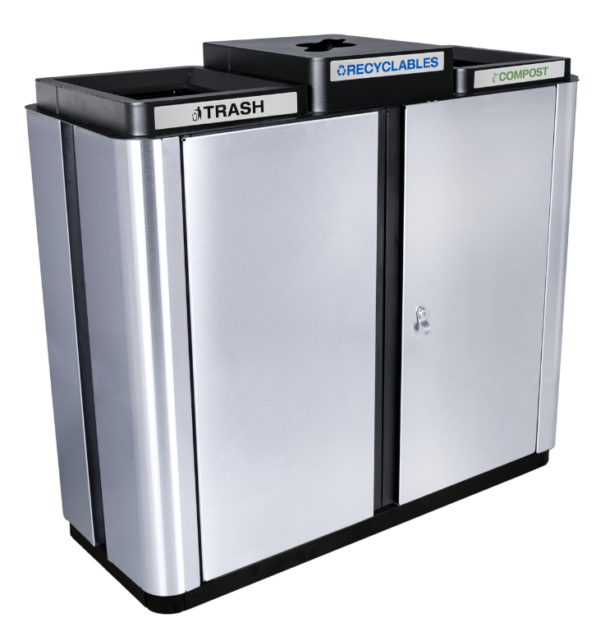

Figure 1 - a standard multi stream trash can.

3.1.2 - Handheld Spectrometers for Plastic Detection

CAWSS’s portability expectations draw inspiration from other on-site spectrographic solutions. Portable, hand-held NIR spectrometers are widely available on the market as plastic waste sorting solutions. These hand-held units still require human analysis and sorting, and are mostly advertised for home use. This technology reduces the error in plastic identification, but still offers no solution to human operating cost.

Portable spectrometer design requires low power consumption, user interface, and compact design. The CAWSS has similar requirements - the CAWSS power consumption must be low enough to be powered by a practical amount of on-unit solar panels, and space constraints call for a compact design. The self-lighting nature of handheld spectrometers offers a tempting alternative to our top-down lighting design for both efficiency of collection and ease of design. User interface, although not required, sets a worthy stretch goal for the CAWSS design. Instillation of handheld

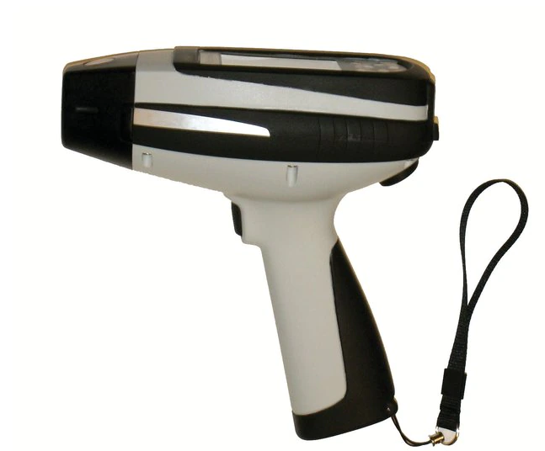

Figure 2 - the ThermoFisher microPHAZIR PC Analyzer

spectrometers into specialized multi-stream waste bins has been contemplated, but appears to have yet to come to fruition.

One example of a handheld NIR spectrometer used in the field is the ThermoFisher microPHAZIRTM PC Analyzer (figure 2). This product was created with efficient assisted hand-sorting in mind. This design weighs a total of 2.75 lbs - portable, and easy for an average person to hold. A tungsten light bulb is utilized for the light source, similar to the CAWSS design. Tungsten bulbs can output the required spectrum while maintaining compact geometry and power requirements. The microPHAZIRTM features a splash proof housing. Similar housing would be a reasonable consideration for CAWSS: it’s not uncommon for people to discard semi-full beverages, which would fry the CAWSS’s electrical system if left unprotected. This would also be considered a stretch goal for this project.

A more sophisticated solution is the trinamiX handheld NIR spectrometer. The trinamiX functions by illuminating the sample from light sources placed around the detector (see figure 2). Results are then sent to a smartphone app via cloud for utilization by the end user. This remote-data feature combined with its small size and 6,000 measurement battery life fulfill its portability requirements.

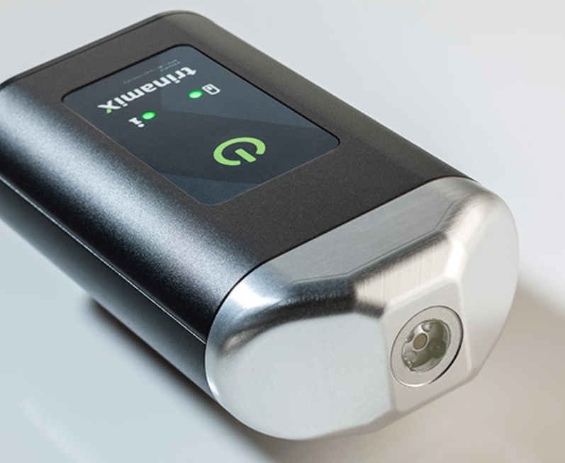

Figure 3 - the trinamiX handheld plastic sorting solution

##### 3.1.3 - Industrial Spectrometry Waste Sorting

Industrial applications of NIR for recyclable sorting have been utilized for some time in modern processing facilities. These join applications of mechanical separation such as rotational separation via holes in a drum and air jet separation, magnetic separation of appropriate metal, and x-ray differentiation.

Commercially sold NIR linescan cameras are commonplace in the industrial waste world due to their ability to process a high volume of waste all at one time. LLA’s KUSTAx.xMSI series of cameras is an excellent example of this (figure 4 - includes pc software and mounting bridge). The wide line scan FOV allows all passing waste to be seen by the system as long as the conveyor belt speed does not pass 3 m/s. This speed is dictated by the speed of the imaging system - an InGaAs array with an imaging speed of 795 frames per second. The three different iterations of the product offer sensitivities in the

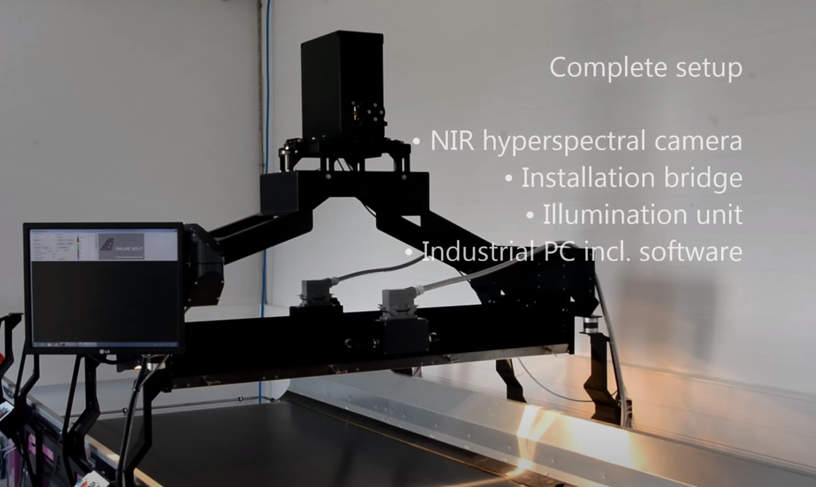

Figure 4 - LLA KUSTA camera setup

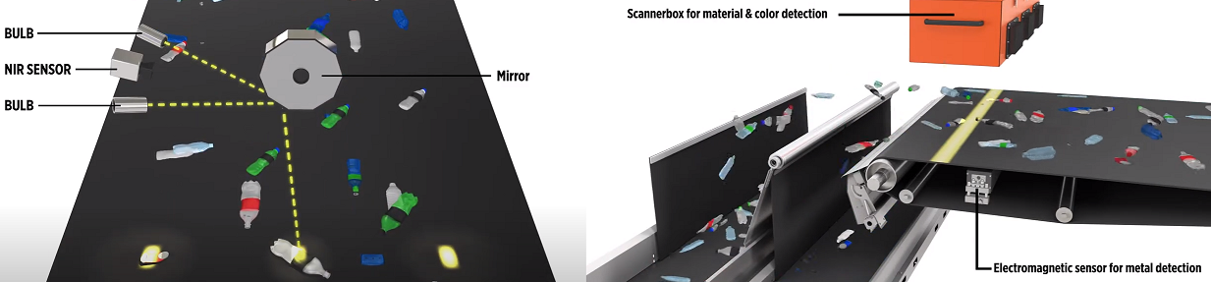

Figure 5 - Tomra Automatic Waste Sorting System

0.95-1.7 um, 1.32-1.9 um, and 1.62-2.19 um ranges, respectively. Software that displays color-coded identification of all passing waste is displayed via the accompanying computer. Similar software will be created for a CAWSS application if time permits.

Tomra’s line scan camera is an alternative linescan product whose internals can be seen in figure 5. It utilizes a “barcode” method of providing light for the linescan system in an evenly distributed manner through its FLYING BEAM® technology. This is accomplished by illuminating a rotating mirror with light, which is then projected across the line. This is then returned to the NIR sensor from the same mirror facet after being reflected from the target. Tomra’s camera specs and sorting speed were not available on its website, most likely because the entire sorting machine is sold as a packaged product.

##### 3.1.4 - Previous Waste Sorting Senior Design Applications

Waste sorting has been tackled in a handful of Senior Design projects in the United States. None, however, offer a comprehensive system that both identifies and automatically sorts incoming objects. Each offers an element which the CAWSS team could potentially utilize in the design of the project.

A team at UC Davis created a Smart Bin. This bin features a compartment in which a camera was mounted. Machine vision was used to train an AI, which in turn is used to identify the type of waste present. The user is required to place the waste into the correct container after identification is complete. Machine vision isn’t required for the CAWSS plastic functionality, but would prove useful if further sorting functionality were required. A similar product that was automated with a pulley system and a trapdoor was created by Rutgers University students.

BioRhythm was created by students at the University of Colorado at Boulder. The concept of this creation was to place an item under a spectrometer, and then place the item in the correct recycling channel as indicated by LED lightstrips. The spectrometer’s design is of particular interest - the IR lightsource was placed in the middle of a ring on sensors (see figure 6). All were placed directly on top of a PCB, offering a compact design and low power consumption. This design could be drawn

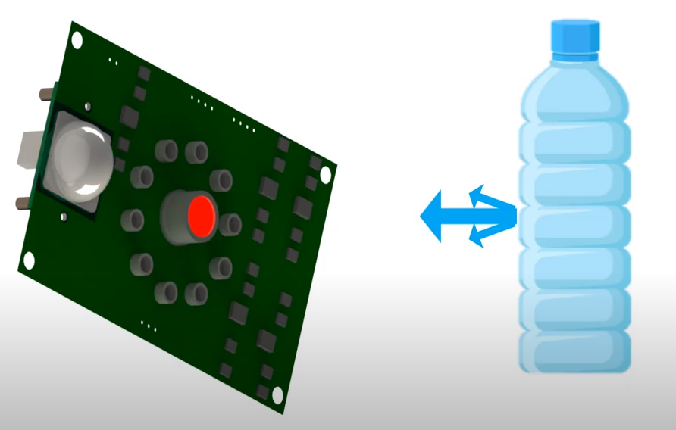

Figure 6 - BioRhythm PCB spectrometer design

from for inspiration for CAWSS, as it requires both compactness and low power consumption.

Mechanical engineering students at University of Mississippi created the Earth Saver - a purely mechanical waste sorting system. The system featured a plastic brush through which glass samples would fall, leaving lighter materials sitting on top. Magnetic components were then sorted out via a magnetic drum, and from there plastic and aluminum were sorted by size and shape. This offers the CAWSS team many ideas for extrapolation on the current design - future iterations could feature metal and glass sorting without requiring further, expensive spectrometer additions.

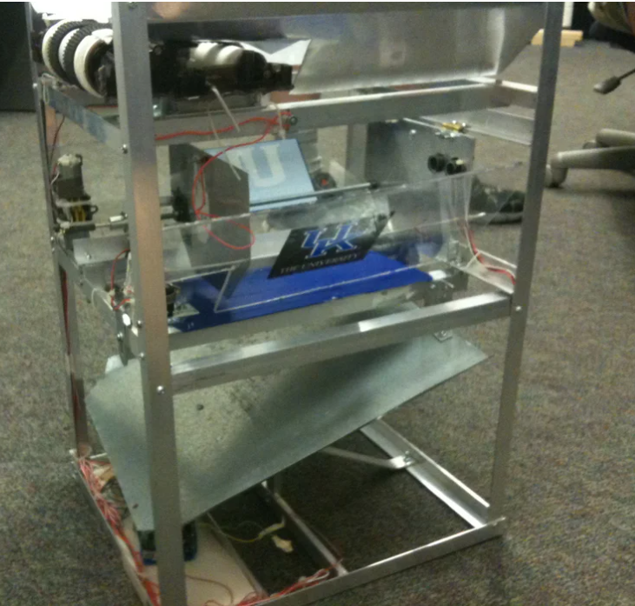  
Figure 7 - Earth Saver Autonomous Material Sorter

### 4 - Related Standards and Realistic Design Constraints

#### 4.1 - Standards

There are no specific standards designed to address a device like ours, but many of our design’s individual systems and components do have relevant technical standards.

Our device is intended for use by customers who will be manually emptying it of trash/recyclables and moving them to a secondary receptacle (such as a dumpster), rather than fully replacing a user’s bins or dumpster. For this reason, any state or local standards for bins do not apply to this design. However, a few standards do apply to parts of this design, such as standards for power supplies and PCBs.

##### 4.1.1 - Power Supply Standards

##### IEC 60906-2:2011

This standard describes the NEMA 5-15-P, otherwise known as the ubiquitous “3-prong grounded plug”, providing 15A 125V AC or 20A 125V AC. It also explains that this type of connection provides protective earthing to any equipment connected to the conductive parts of the socket, and electronically separates this earthing from the rest of the cabling to reduce electrical noise.

This standard applies to our system, which will use a standard North American wall outlet as a backup power source. The IEC 60906-2: 2011 standard describes all the requirements to be compatible with these outlets and cables, and critically also helps isolate our system from electrical noise.

##### 4.1.2 - PCB Standards

##### IPC-2221B

Our system will be using at least one printed circuit board to connect all of the parts of our design. The Association Connecting Electronics Industries, otherwise known as the Institute of Printed Circuits (IPC) sets some standards for all types of printed circuit boards.

The IPC-221B standard describes fundamental design requirements for the design of printed circuit boards, as well as mounting components to them and interconnecting these structures on the board. Any revision of our PCB will include these components, and thus this standard applies to our design.

##### 4.1.3 - Power Electronic Converter Systems

##### IPC 62477-1:2012

This standard describes many of the components used to perform power conversion in systems not exceeding 1,000V AC or 1,500V DC, and their control, protection, monitoring, and measurement. While much of this standard is for specific systems like uninterruptible power supplies, we nonetheless expect to use simple AC-DC and DC-DC power conversion circuits in our design.

In particular, the safety guidelines outlined in this standard contribute to reducing the risk of fire, thermal, and shock hazards. This is incredibly important to the design of our device, as it is intended to be used in public, outdoor spaces and must remain safe to place in these places.

##### 4.1.4 - Requirements for Battery Chargers

##### IEC 60335-2-29:2016

This standard deals with the safety of battery chargers for household and similar use. The devices referenced must not exceed 120V DC, and their rated voltage must be less than 250V. The standard details many of the common hazards of these chargers, and guidelines to ensure safety in their design.

We intend to use a battery system to provide power to our device, and must ensure that this system is not overloaded dangerously or otherwise configured in a way that is unsafe to the public. Our battery charger will be fully integrated into our design, rather than as an external one - for this reason, it must fully follow any safety guidelines to avoid fire, electrical, or chemical hazards caused by the system.

##### 4.1.5 – Solar Photovoltaic Power Supply Systems

##### IEC 60364-7-712:2017

This standard outlines the proper use and design of solar power supply systems. It explains things like the ideal placement and mounting of panels, and like the rest of our power standards, provides guidelines essential for preventing fire and electrical hazards, as well as to ensure no damage occurs to our solar panel or other components powered by this subsystem.

We intend to use a solar panel to provide power to our device, particularly to charge our battery. Solar panels are complex, delicate equipment, and we want to avoid any damage to the panel itself due to misconfiguration. Conversely, we also need to make sure that the power system supporting this panel can safely deal with the panel's output, without damaging any of its own components, as well as the rest of the device.

##### 4.1.6 – Plastics Recycling Standards

##### ISO 15270:2008

This standard provides guidelines for the recycling industry as a whole for the recovery and recycling of plastic waste. It details the potential sources of plastic waste, as well as the amount of work necessary to reclaim this waste.

Our design is a part of the very beginning of the recycling chain, sorting materials and removing those which cannot be recycled. While the specifics of plastic waste recovery are not a part of this design's scope, this standard provides necessary information about the types of plastic we will need to sort, and some of their characteristics. Additionally, it provides some context for the impact this design can potentially have on this industry.

#### 

#### 4.2 - Design Impact of Relevant Standards

As discussed previously, while there may not be a specific standard describing the device we have set out to design, there are many standards which can be applied to its components. A crucial place to start are the general standards regarding the recycling of plastics.

Much of the ISO standard for Plastics Recycling (ISO 15270:2008) is in reference to the industrial processes used to reclaim usable material from plastics. However, parts of this standard do fall under the high-level scope of our project. Definitions of plastic types, as well as which ones are considered “recyclable” will guide the spectral analysis that is the core of our design.

Many different standards can be applied to the electrical components of our design. At the lowest level, we must follow some of the basic guidelines for proper PCB design (IPC-221B). Beyond this, there are several standards that apply to our power systems; our solar panel, battery, backup AC-DC converter, and even the simple DC-DC conversion circuits in our design must all be designed to respect the safety standards for these types of systems. Following all of these standards for electrical systems will ensure that we lower all possible risk of fire, electrical, and chemical hazards, which will be extremely important for a device intended for public, outdoor use.

### 5 - Project Hardware and Software Design Details

#### 

#### 5.1 - Initial Design Architectures and Related Diagrams

5.1.1 - Initial design block diagrams

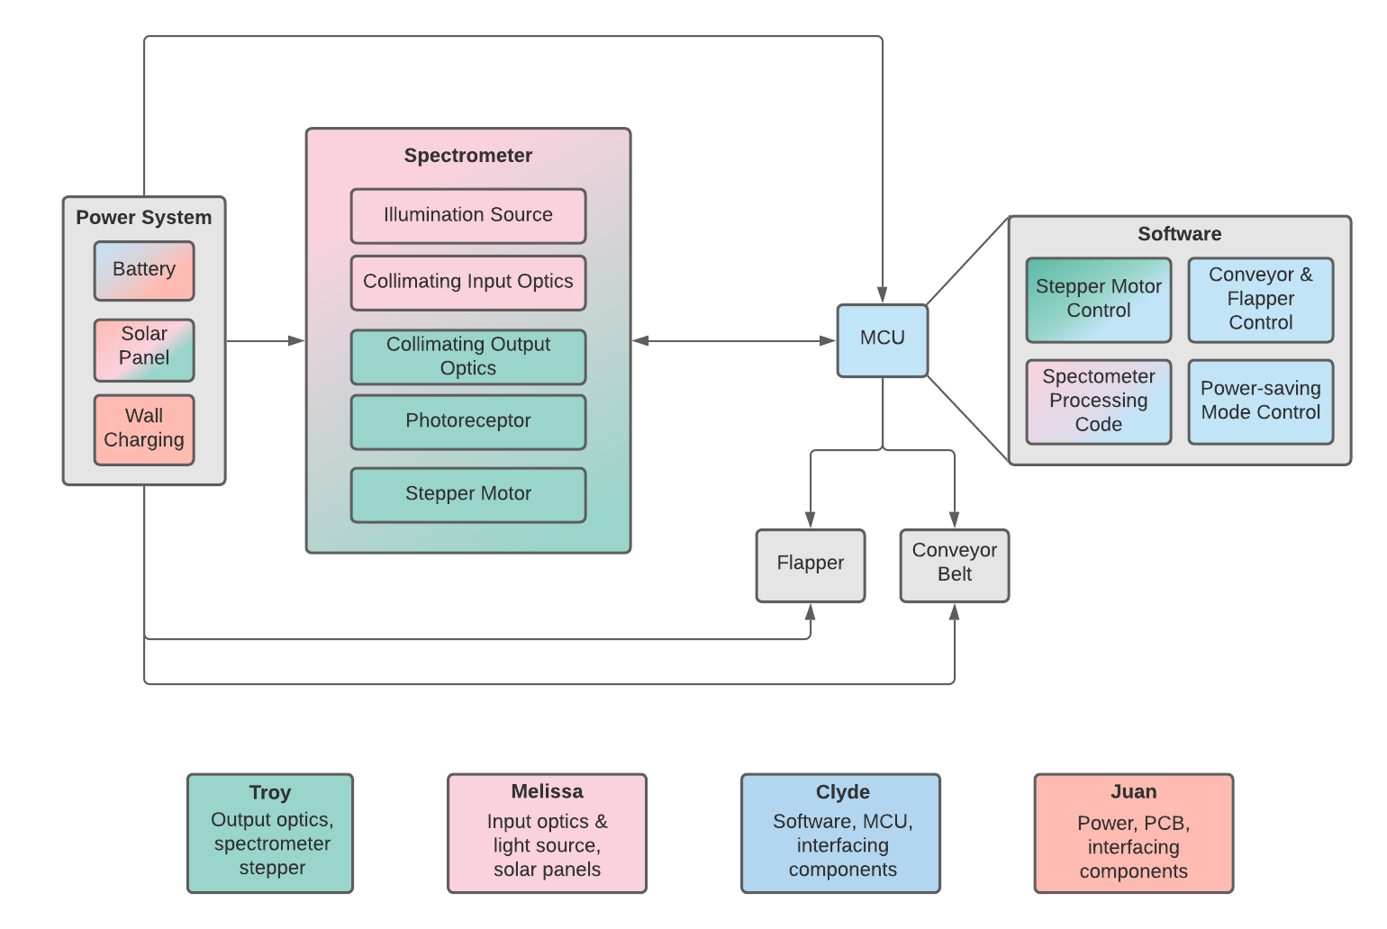

**Figure 1**. Block diagram describing the roadmap for product development.

### 

**Figure 2**. Software flow chart of the planned logic for required tasks.

#### 

#### 5.1.2 - Design Sketch

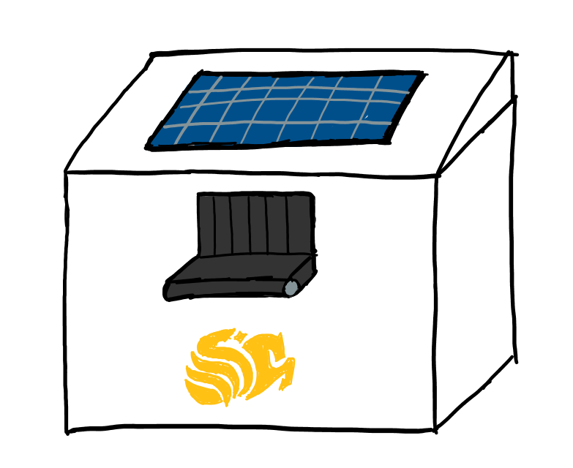

**Figure 3**. Outside design of CAWSS

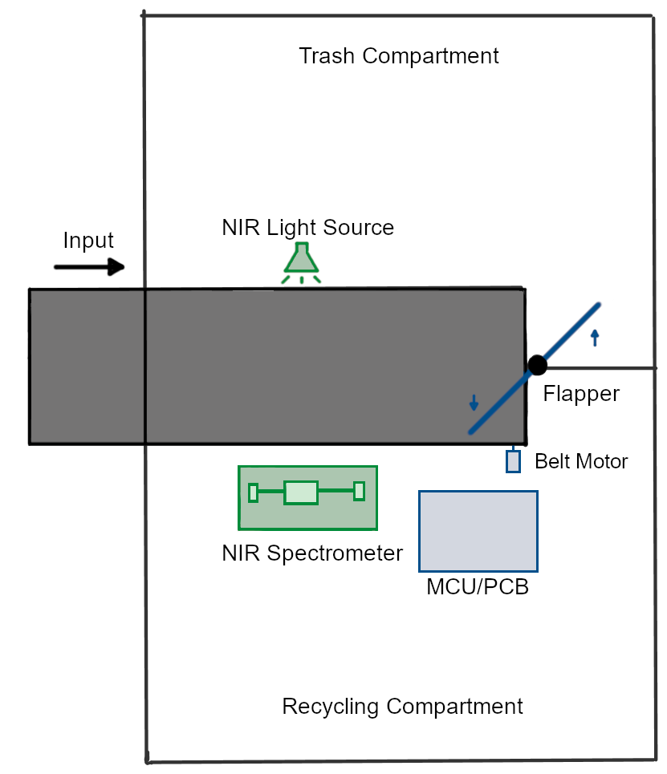

**Figure 4.** Inside design of CAWSS

### 

### **5 - Initial Project Milestones**

5.4 Decision Matrix

|  |  |  |
| --- | --- | --- |
| Criteria | Build NIR Spectrometer | Borrow OceanOptics NIR Spectrometer |
| Resolution | 0 | + |
| Cost to build | - | + |
| Electrical Power Usage | 0 | 0 |
| Hazardous Emissions | 0 | 0 |
| Durability | - | + |
| ROI Potential | + | - |
| Ease of Use | - | + |
| Time taken to implement | - | 0 |
| Alignment to strategy | + | + |
| Variability | - | 0 |
| Sum of Pros | 2 | 5 |
| Sum of Cons | 5 | 1 |
| Sum of Neutrals | 3 | 4 |
| Total | -3 | 4 |

|  |  |
| --- | --- |
| + | Pro |
| 0 | Average |
| - | Con |

**Table 4**. Decision Matrix

5.5 Analysis of Decision Matrix

Overall, the decision matrix that we constructed provided useful and valuable insight that can help us further investigate which route to continue down. When considering making our own Near-Infrared Spectrometer, several advantages present themselves. First, it could have a high return on investment in the future if production was scaled up to manufacture a higher volume of our design. Not only would we avoid purchasing costly spectrometers from third party vendors, our team could also make improvements specific to our application such as increased resolution in the part of the electromagnetic spectrum we are analyzing. Some of the disadvantages are that the initial capital investment to develop our own NIR spectrometer would be quite high when compared to renting or borrowing one. Also, our design is most likely not as durable as some of our competitors.

When considering borrowing an Ocean Optics NIR spectrometer, the biggest advantage is that it requires no initial investment as we would be borrowing it for free. This would allow us to save on the overall cost of the design and potentially use that money to further improve other components. Another advantage is that the Ocean Optics NIR spectrometer is relatively user friendly and easy to implement for the application that it will be needed for. While both of these options present distinct advantages and disadvantages, we will ultimately choose the option that presents itself as the most beneficial for the long term feasibility of our concept and design.

### **8 - Administrative Content**

Project milestones have been considered with both senior design milestone dates and self-set team milestone dates. These considerations were made with both grades and project completion under consideration. Some due dates for Senior Design 2 are estimates.

8.1 - Milestones

The milestones required for Senior Design 1 are listed in table 2. These milestones must be met for successful completion of Senior Design 1. These assignments additionally serve as a guide for project development.

8.1.1 - Class Milestones SD2

The significant Senior Design 2 milestones are listed in table 3. The lack of a 2021 Senior Design 2 syllabus resulted in some due dates being estimated. The final form of CAWSS will be demonstrated at the Senior Design 2 demo day.

|  |  |
| --- | --- |
| Milestone | Due Date |
| Bootcamp Assessment | 6/04/2021 |
| Divide and Conquer | 6/11/2021 |
| Divide and Conquer 2 | 6/25/2021 |
| Standards Assignment | 7/02/2021 |
| 60 Page Documentation Draft | 7/09/2021 |
| 100 Page Submission | 7/23/2021 |
| Optics Demo | 7/27/2021 |
| Final Paper | 8/03/2021 |

**Table 2**. Senior Design 1 Milestones

8.1.2 - Team Milestones

The development modules set by the team are summarized in the block diagram in figure 2. Each module (indicated in pink) marks an important step in completing the project in a timely and efficient manner. The subgroup responsible for each submodule is indicated with their associated color.

The spectrometer was chosen as the first milestone since it is the central component of the CAWSS. It will be presented as the optical prototype during the optics demo on July 27th. The CAWSS housing and PCB will be developed and assembled during the period between SD1 and SD2. This will allow the team to produce a working product before the Senior Design demo in late fall.

|  |  |
| --- | --- |
| Milestone | Due Date |
| Critical Design Review | Early SD2 - exact date TBA |
| Midterm Demo | Mid SD2 - exact date TBA |
| Final Demo | End SD2 - exact date TBA |

**Table 3**. Senior Design 2 Milestones

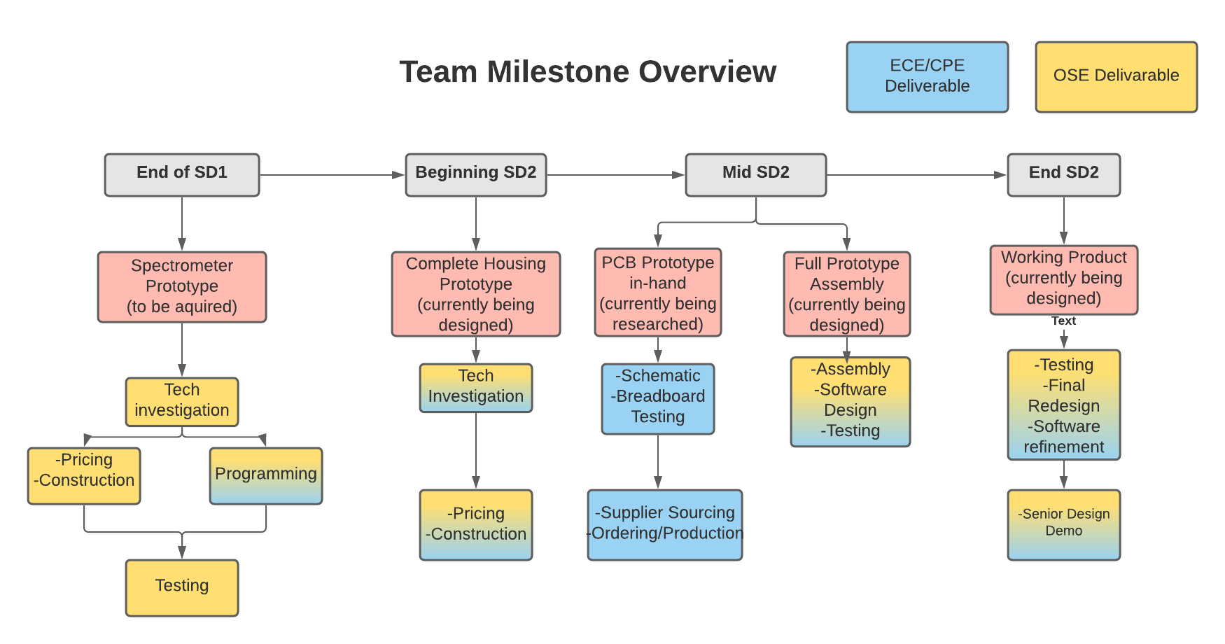**Figure 4**. Team Milestones with Executable Steps

8.2 - Initial Budget and Financing Discussion

The estimated optical budget (tables 4) and electrical budgets (tables 5 and 6) is presented below. All financing is currently being provided out-of-pocket by team members up to a maximum of $2000. Duke Energy, Siemens, and OUC will be contacted in an attempt to borrow solar panels. Newport, Thorlabs, and Edmund Optics will be contacted in search of donations or loans. Any successful acquisition attempts could result in significant cost reduction. This table will be updated as needed so as to reflect any changes in design and component sponsorship.

The current estimated cost of our project is roughly $1,150.44. It is hoped that this amount can be reduced by reaching out to appropriate donors for many of the optical components. The NIR range is a less commonly used portion of the optical spectrum, and offers little in the way of affordable components. This was taken into account when selecting the project, and the budget was developed accordingly. NIR photodiodes are generally made of InGaAs, and prove to be wildly expensive in large arrays. The single pixel photodiode was chosen to minimize this cost, and brought what would otherwise have cost thousands of dollars into the double-digit range.

|  |  |  |  |  |
| --- | --- | --- | --- | --- |
| Component Type | Component | Manufacturer | Price | Quantity |
| Optics | 100 W Solar Cell | Grape Solar | $81.29 | 2 |
| Optics | InGaAs pixel  (0800-3111-111-ND) | Advanced Photonix | $29.68 | 1 |
| Optics | Ø50 µm, 0.22 NA, Low OH, SMA to SMA Fiber Patch Cable 2m | Thorlabs | $73.86 | 1 |
| Optics | Slit Tape | Wapodeai | $10 | 2 |
| Optics | Ruled Reflective Diffraction Grating (GR13-0610) | Thorlabs | $71.15 | 1 |
| Optics | 4mm Aperture VIS/NIR Fiber Optic Collimator, SMA | Edmund Optics | $155 | 1 |
| Optics | Halogen Light | Sylvania | $19.65 | 1 |
| Optics | PF05-03-P01 - Ø1/2" Protected Silver Mirror | Thorlabs | $32.84 | 1 |

**Table 4**. Estimated budget for optical parts.

|  |  |  |  |  |
| --- | --- | --- | --- | --- |
| Electrical | Stage actuator with stepper motor | Toauto | $67.00 | 1 |
| Electrical | Linear Regulator LT3042 | Analog Devices | $8.79 | 1 |
| Electrical | STM32 Nucleo-32 development board with STM32L432KC MCU | Diginex | $23.99 | 2 |
| Electrical | AD8656 op-amps | Analog Devices | $3.85 | 2 |
| Electrical | Analog to Digital Converter | Analog Devices | $12.11 | 1 |
| Electrical | SFH 4545 IR LED | ORAM Opto Semiconductor | $0.81 | 2 |
| Electrical | TSSP4038 IR Receiver | Vishay Semiconductor | $1.12 | 2 |

**Table 5.** Estimated budget for electrical interface parts

|  |  |  |  |  |
| --- | --- | --- | --- | --- |
| Electrical | L293D Motor Controller | STMicroelectronics | $4.26 | 1 |
| Electrical | DC Motor | Hilitand | $37.93 | 1 |
| Electrical | High Torque Servo | Adafruit | $11.95 | 1 |
| Electrical | ULN2003 Stepper Driver IC | Diodes Incorporated | $0.46 | 1 |
| Electrical | 7.2V 5000mAh NiMH High Capacity Battery Pack, 2 pack | Geilienergy | $32.99 | 1 |
| Electrical | PCB | Vendor TBD | Estimated $300 | 1 |
| Misc | Conveyer Belt | Treadmill Doctor | $64.99 | 1 |
| Housing | 25mm T-Slot Quad Track | Orange Aluminum | $23.50 | 1 |

**Table 6.** Estimated budget for housing and conveyer parts

References

1. *Are you guilty of "Wishful Recycling"?* Sierra Club. (2019, May 31). https://www.sierraclub.org/san-francisco-bay/blog/2019/05/are-you-guilty-wishful-recycling.
2. *Belt Speed*. vCalc. (n.d.). https://www.vcalc.com/wiki/vcalc/belt+speed.
3. Cory, O. (2020, September 30). *'Stop Wishful Recycling,' Says City of Arcata*. Redheaded Blackbelt. https://kymkemp.com/2020/09/30/stop-wishful-recycling-says-city-of-arcata/.
4. Cuauhtémoc Araujo-Andrade, E. B. (n.d.). *Review on the photonic techniques suitable for automatic monitoring of the composition of multi-materials wastes in view of their posterior recycling - Cuauhtémoc Araujo-Andrade, Elodie Bugnicourt, Laurent Philippet, Laura Rodriguez-Turienzo, David Nettleton, Luis Hoffmann, Martin Schlummer, 2021*. SAGE Journals. https://journals.sagepub.com/doi/10.1177/0734242X21997908.
5. *Earth Day Challenge: Stop Wishful Recycling*. The Watershed Project. (2019, April 11). https://thewatershedproject.org/earth-day-challenge-stop-wishful-recycling/.
6. *Flame-NIR+ Spectrometer*. Flame NIR+ Spectrometer | Ocean Insight. (n.d.). https://www.oceaninsight.com/products/spectrometers/general-purpose-spectrometer/flame-series/FLAME-NIR/.
7. Ocean Optics. (2017, May 24). *How Does a Spectrometer Work?* YouTube. https://www.youtube.com/watch?v=OI3pIvLhVcc.
8. Valley Waste Service. (n.d.). What Happens if You Put Non-Recyclable Items into Recycling? https://www.valleywasteservice.com/valley-waste-news/what-happens-if-you-put-non-recyclable-items-into-recycling-4034.
9. YouTube. (2015, June 12). *Identification and Analysis of Plastics in Recycling by NIR Hyperspectral camera KUSTA1.9MSI*. YouTube. https://www.youtube.com/watch?v=eIZIWSj7jIg.
10. Zhu, S., Chen, H., Wang, M., Guo, X., Lei, Y., & Jin, G. (2019, April 12). *Plastic solid waste identification system based on near infrared spectroscopy in combination with support vector machine*. Advanced Industrial and Engineering Polymer Research. <https://www.sciencedirect.com/science/article/pii/S254250481830011>
11. IEC 60335-2-29:2016+AMD1:2019 CSV | IEC Webstore. (2019, March 29). Webstore.iec.ch; International Electrotechnical Comission. https://webstore.iec.ch/publication/64908
12. IEC 60364-7-712:2017 | IEC Webstore | rural electrification, LVDC. (2017, April 10). Webstore.iec.ch; International Electrotechnical Comission. https://webstore.iec.ch/publication/28213
13. IEC 60906-2:2011 | IEC Webstore. (2011, May 12). Webstore.iec.ch; International Electrotechnical Commission. https://webstore.iec.ch/publication/3883
14. IEC 62477-1:2012 | IEC Webstore. (2012, July 24). Webstore.iec.ch; International Electrotechnical Commission. https://webstore.iec.ch/publication/7080
15. ISO 15270:2008. (2008, June). ISO; International Organization for Standardization. <https://www.iso.org/standard/45089.html>
16. QFD Online - Free House of Quality (QFD) Templates for Excel. (n.d.). Qfdonline.com. Retrieved June 25, 2021, from <http://qfdonline.com/templates/>